**Physical Movement of the Player**

**(This shows how to add realistic movement to an object)**

1. **Create a Plane.**

GameObject—3D Object—Plane.

Name the plane Ground. Set the position on 0,0,0 and scale on 3,3,3

1. **Create a Sphere.**

GameObject—3D Object—Sphere.

Name the Sphere Player and set to position 0.5 on the Y Axis

1. **Create a Rigidbody for the Player.**

Select Player--Add Component—Rigidbody

1. **Create a Script for the Player which will allow us to move and turn the object under our control.**

Select Player--Add Component—New Script—Name Script (PlayerControll)—Sellect the Script and open it from the Inspector window.

1. **The Script.**

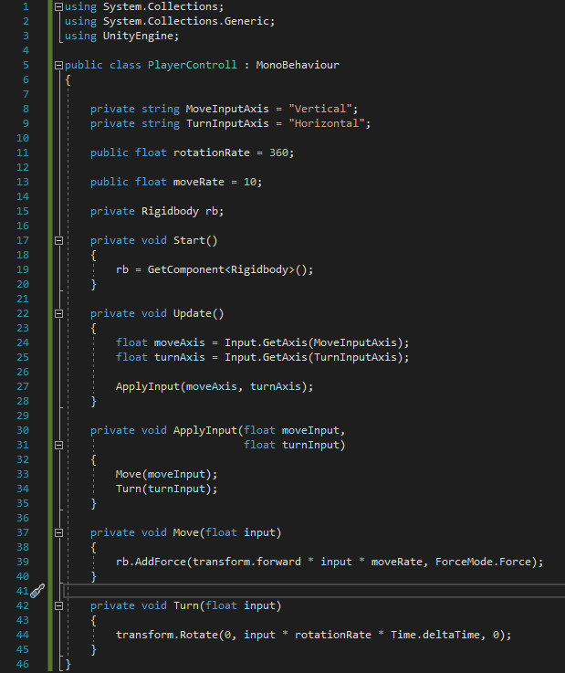

Line 8,9 Axis function to put values based on a name of an axis. (Vertical w,s +W -S) (Horrizontal a,d -A +D).

Line 11 Rotation per second.

Line 13 Speed of Unity units per second.

Line 15 Reference to the Rigidbody.

Line 19 Seizes the reference to the Rigidbody whenever the script starts.

Line24,25 Seizes the value between -1 and 1 based on Axis.

Line 27 Updates the position and rotation.

Line 30,33,34 Applies the input of move and turn.

Line 39 Moves the object to a certain direction with a certain speed based on the input of -1 and 1.

Line 44 Rotates the object to a certain direction with a certain speed per second based on the input of -1 and 1.

1. **Freeze Position & Rotation.**

Rigidbody—Constraints—Freeze Position on Y Axis—Freeze Rotation on X and Z Axis.

1. **Play around for realism.**

By changing the Mass, Drag, Rotation Rate and Move Rate you can achieve different kinds of moment. Mass and Drag can be found under the Rigidbody, and Rotation Rate, Move Rate under the Script.